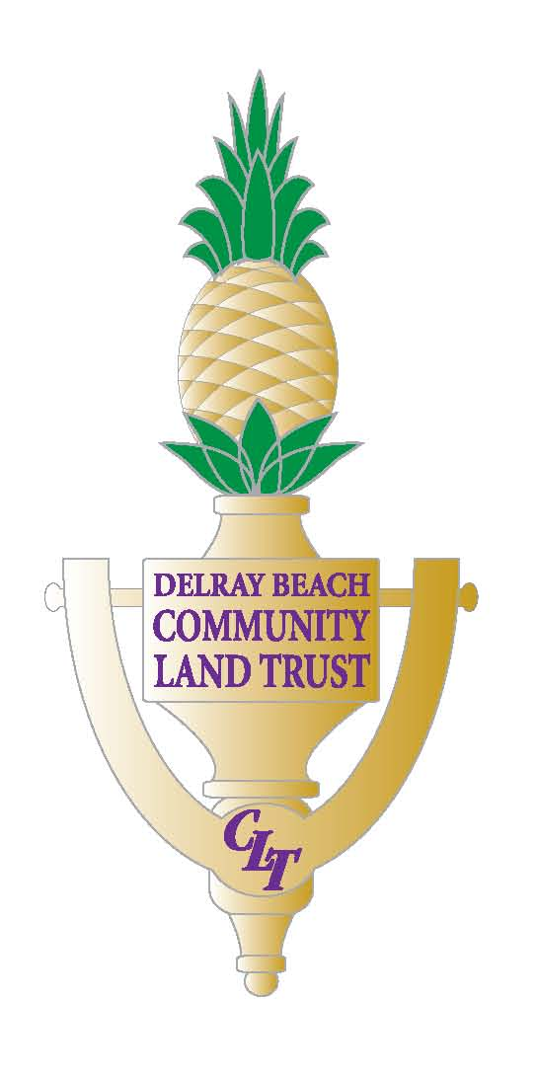
Please be advised that if a person decides to appeal any decision made by the Delray Beach Community Land Trust, Inc. with respect to any matter considered at this meeting, such person will need a record of the proceedings, and that, for such purpose, such person may need to ensure that a verbatim record of the proceedings is made, which record includes the testimony and evidence upon which the appeal is based. The Delray Beach Community Land Trust, Inc. neither provides nor prepares such record.

REGULAR BOARD OF DIRECTORS MEETING AGENDA
June 25th, 2026
6:00pm
ZOOM

Call to Order:

Roll Call
1. Approval of Agenda
2. Approval of Minutes:
- Regular Meeting Minutes from April 23rd, 2026
3. Public Comments (Note: comments are limited to 2 minutes in duration)

Consent Agenda:
4a. Report: Progress Report as of March 31st, 2026
4b: Reports: Non-Owned 2nd Quarter Property Management
- Palm Manor Apartments-31, 39, 45 SW 9th Ave
- Courtyards @ SW 12th Ave Six (6) Duplexes
- 121 SW 10th Ave-Duplex
- 47 SW 8th Ave-Single Family Unit
4c. 990 Tax Return 9/30/2025
4d. 2nd Quarter AGuide Funding Report

Old Business:
5. 2021-20 Homebuyer Candidate Update-Julien
6. 2023-32 Homebuyer Candidate Update-Israel
7. 2023-08 Homebuyer Candidate Update/Leriche
8. Special Mtg 308 SW 3rd Work Assignment-Changes

New Business:
9. 2026-07 2nd Quarter Financial Summary

Discussion:
10. DBCRA RFP 2026-01
- Disposition of Three CRA-Owned Vacant Lots For The Development of Affordable/Workforce Housing
11. Florida Housing 2026 Annual Conference/Southeast Community Land Trust Summit

Other Business:
12. Comments by Directors
13. Comments by CEO

Join Zoom Meeting
https://us06web.zoom.us/j/84803553412?pwd=YVE2yYx9bbPeCPaLYcJCWyHRlCB73C.1

Meeting chat link
https://us06web.zoom.us/launch/jc/84803553412

Meeting ID: 848 0355 3412
Passcode: 270260

One tap mobile
+13092053325,,84803553412#,,,,*270260# US

